Development Asia – Insight

The insight article provides a channel for development professionals to give their expert opinion based on quantitative/qualitative data. Topics include innovative ideas/solutions and the application of new technologies in addressing development challenges as defined by the Sustainable Development Goals (SDGs).

This template may also be used to talk about ongoing programs/projects that are too early in implementation to have any measurable outcomes and impacts. It would be ideal, however, if the practitioners could support their claims with interim markers/measures demonstrating progress toward achieving the intended outcomes/impacts and/or the SDGs.

View sample insight articles on the website. For more information, contact info@development.asia.

- Basic Information

1.1. Expert’s bio
Expert  (50 words for each bio) | Please provide a brief bio of the expert(s) associated with the content. The institution that holds the copyright of the original content may be listed along with the expert. Please provide a brief introduction of the institution.  Please include a link to the expert's LinkedIn page if available. Other social media links and contact information are welcome.  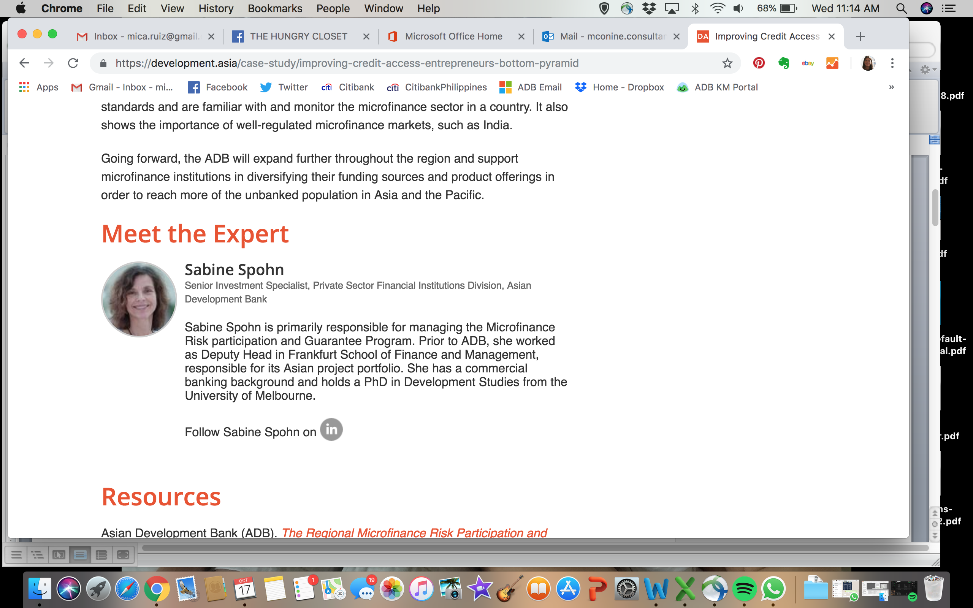

1.2. Check box for sectors
Sector | Which sector does this article primarily address? You may select more than one but not more than three sectors.

 | Agriculture and natural resources |  | Health
 | Capacity development |  | Industry and trade
 | Civil society |  | Information and communications technology
 | Climate change |  | Poverty
 | Economics |  | Private sector development
 | Education |  | Regional cooperation and integration
 | Energy |  | Social development and protection
 | Environment |  | Transport
 | Finance sector development |  | Urban development
 | Gender |  | Water
 | Governance and public sector management

2.3. Check box for SDGs
SDGs | Choose which Sustainable Development Goal (SDGs) is most relevant to this article. Select up to 3 SDGs only.

 | Goal 1: No Poverty |  | Goal 10: Reduced Inequalities
 | Goal 2: Zero Hunger |  | Goal 11: Sustainable Cities and Communities
 | Goal 3: Good Health and Well-being |  | Goal 12: Responsible Consumption and Production
 | Goal 4: Quality Education |  | Goal 13: Climate Action
 | Goal 5: Gender Equality |  | Goal 14: Life Below Water
 | Goal 6: Clean Water and Sanitation |  | Goal 15: Life on Land
 | Goal 7: Affordable and Clean Energy |  | Goal 16: Peace, Justice and Strong Institutions
 | Goal 8: Decent Work and Economic Growth |  | Goal 17: Partnerships for the Goals
 | Goal 9: Industry, Innovation and Infrastructure

1.4. Keywords
Keywords | Add 5–10 keywords or phrases, including the topic and country/region (if applicable) to be included in the metadata.

1.5. List of attachments
Photos and other materials | - Portrait photo of expert or and/or high-resolution logo of institution (see 1.1).  - Please provide a photo that is most relevant to the content with a brief caption that tells the location and context of the photo. If you are submitting a copyrighted photo, please ask the copyright owner to sign the attached consent form.  - Photo caption:  - Context:  - Date:  - Location:  - You may submit additional materials that can support the content, such as annexes, infographics, videos, before-and-after photos, design plans, and other materials.

- Content

2.1. Introduction
Introduction  (100 words) | An opening paragraph detailing your opinion, perspective, and/or idea. Highlight its relevance toward achieving the SDGs.

2.2. Analysis
Analysis  (800 words) | Provide data, research, facts, or findings upon which the insights are built. You may include additional background information to support your argument.

2.3. Implications
Implications  (200 words) | Based on the analysis above, discuss the implications of your findings in terms of progressing toward the SDGs.  If necessary, provide concise suggestions on actions that readers/policy makers/project officers and others can take.

2.4. Resources
References | Please provide a list of references and/or recommended content (journal articles, publications, etc.) that support your insights and ideas in addressing the development challenges as defined by the SDGs.

2.5. Blurb
Short one-sentence blurb  (Up to 150 characters, including spaces) | Write a short, relevant summary to inform and interest users. This one-sentence blurb will be displayed on the homepage and search results page of not only the Development Asia website but also search engines, such as Google.  A good blurb that contains relevant keywords will help researchers on the internet find your article.  Our editors can help you optimize your one-sentence blurbs for search engines.

2.6. Title
Suggest a title  (15 words) | Please suggest a title that is intriguing and draws the attention of the target audience.

2.7. Ongoing program/project at a glance (Optional)
Sidebar to Program/Project Snapshot | - Main goal  - Targets  - Technical details: Any information relevant to understanding the scale of a program/project, e.g. how many kilometers of a road with how many lanes.  - Projected total cost in local currency and USD  - Source of financing  - Duration in number of years, including starting date.  - Planning Agency  - Implementing/Executing Agency  - Major stakeholders

